Table of Contents
- 1.0 Introduction
          - Figure 1. PocketBeagle Home Page
- 2.0 Change History
    - 2.1 Document Change History
          - Table 1. Change History
    - 2.2 Board Changes
          - Table 2. Board History
      - 2.2.1 PocketBone
      - 2.2.2 Rev A1
      - 2.2.3 Rev A2
- 3.0 Connecting Up PocketBeagle
    - 3.1 What’s In the Package
          - Figure 2. PocketBeagle Package
          - Figure 3. PocketBeagle Package Insert
    - 3.2 Connecting the board
    - 3.3 Tethered to a PC using Debian Images
          - Figure 4. Tethered Configuration
      - 3.3.1 Getting Started
          - Figure 5. Getting Started Page
          - Figure 6. Download Latest Software Image
          - Figure 7. Download Etcher SD Card Utility
          - Figure 8. Select the PocketBeagle Image
          - Figure 9. Burn the Image to the SD Card
          - Figure 10. Insert the microSD Card into PocketBeagle
          - Figure 11. Insert the micro USB Connector into PocketBeagle
          - Figure 12. Insert the USB connector into PC
          - Figure 13. Board Power LED
          - Figure 14. User LEDs
      - 3.3.2 Accessing the Board and Getting Started with Coding
          - Figure 15. Interactive Quick Start Guide Launch
          - Figure 16. Enable a Network Connection
          - Figure 17. Launch Cloud9 IDE
      - 3.3.3 Powering Down
          - Figure 20. Power Button
    - 3.4 Other ways to Connect up to your PocketBeagle
- 4.0 PocketBeagle Overview
    - 4.1 PocketBeagle Features and Specification
          - Table 3. PocketBeagle Features
      - 4.1.1 OSD3358-512M-BSM System in Package
    - 4.2 Board Component Locations
          - Figure 21. Key Board Component Locations
- 5.0 PocketBeagle High Level Specification
    - 5.1 Block Diagram
          - Figure 22. PocketBeagle Key Components
    - 5.2 System in Package (SiP)
          - Figure 23. OSD335x SIP Block Diagram
    - 5.3 Connectivity
      - 5.3.1 Expansion Headers
          - Figure 24. PocketBeagle Expansion Headers
      - 5.3.2 microSD Connector
          - Figure 25. microSD Connector
      - 5.3.3 USB 2.0 Connector
          - Figure 26. USB 2.0 Connector
      - 5.3.4 Boot Modes
          - Table 4. UART Pins on Expansion Headers for Serial Boot
    - 5.4 Power
          - Table 5. Power Inputs Available on Expansion Headers
          - Table 6. Power Outputs Available on Expansion Headers
          - Table 5. Ground Pins Available on Expansion Headers
    - 5.5 JTAG Pads
          - Figure 27. JTAG Pad Connections
    - 5.6 Serial Debug Port
          - Figure 28. Serial Debug Connections
- 6.0 Detailed Hardware Design
    - 6.1 OSD3358-SM SiP Design
      - 6.1.1 SiP A OSD3358 SiP System and Power Signals
          - Figure 29. SiP A OSD3358 SiP System and Power Signals
      - 6.1.2 SiP B OSD3358 SiP JTAG, USB & Analog Signals
          - Figure 30. SiP B OSD3358 SiP JTAG, USB & Analog Signals
      - 6.1.3 SiP C OSD3358 SiP Peripheral Signals
          - Figure 31. SiP C OSD3358 SiP Peripheral Signals
      - 6.1.4 SiP D OSD3358 SiP System Boot Configuration
          - Figure 32. SiP D OSD3358 SiP System Boot Configuration
      - 6.1.5 SiP E OSD3358 SiP Power Signals
          - Figure 33. SiP E OSD3358 SiP Power Signals
      - 6.1.6 SiP F OSD3358 SiP Power Signals
          - Figure 34. SiP F OSD3358 SiP Power Signals
    - 6.2 MicroSD Connection
          - Figure 35. microSD Connections
    - 6.3 USB Connector
          - Figure 36. USB Connection
    - 6.4 Power Button Design
          - Figure 37. Power Button
    - 6.5 User LEDs
          - Figure 38. User LEDs
          - Table 6. User LED Control Signals/Pins
    - 6.6 JTAG Pads
          - Figure 39. JTAG Pads Design
    - 6.7 PRU-ICSS
      - 6.7.1 PRU-ICSS Features
      - 6.7.2 PRU-ICSS Block Diagram
          - Figure 40. PRU-ICSS Block Diagram
      - 6.7.3 PRU-ICSS Pin Access
          - Table 6. PRU0 and PRU1 Access
- 7.0 Connectors
    - 7.1 Expansion Header Connectors
          - Figure 41. Expansion Headers for PocketBeagle
          - Figure 42. Expansion Header Popular Functions - Color Coded
    - 7.1.1 P1 Header
          - Figure 43 P1 Header
          - Table 7. P1 Header Pinout
    - 7.1.2 P2 Header
          - Figure 44. P2 Header
          - Table 8. P2 Header Pinout
    - 7.2 mikroBUS socket connections
          - Figure 45. mikroBUS
          - Figure 46. PocketBeagle Both Headers
    - 7.3 Setting up an additional USB Connection
- 8.0 PocketCape Support
- 9.0 PocketBeagle Mechanical
    - 9.1 Dimensions and Weight
- 10.0 Additional Pictures
          - Figure 47. PocketBeagle Front BW
          - Figure 48. PocketBeagle Back BW
- 11.0 Support Information
    - 11.1 Hardware Design
    - 11.2 Software Updates
    - 11.5 Export Information
    - 11.4 RMA Support
    - 11.5 Getting Help

1.0 Introduction
This document is the System Reference Manual for PocketBeagle and covers its use and design. PocketBeagle is an ultra-tiny-yet-complete Linux-enabled, community-supported, open-source USB-key-fob-computer. PocketBeagle features an incredible low cost, slick design and simple usage, making it the ideal development board for beginners and professionals alike. Simply develop directly in a web browser providing you with a playground for programming and electronics. Exploring is made easy with several available libraries and tutorials with many more coming.
PocketBeagle will boot directly from a microSD card. Load a Linux distribution onto your card, plug your board into your computer and get started. PocketBeagle runs GNU.Linux, so you can leverage many different high-level programming languages and a large body of drivers that prevent you from needing to write a lot of your own software.
This design will keep improving as the product matures based on feedback and experience. Software updates will be frequent and will be independent of the hardware revisions and as such not result in a change in the revision number of the board. A great place to find out the latest news and projects for PocketBeagle is on the home page beagleboard.org/pocket

Figure 1. PocketBeagle Home Page
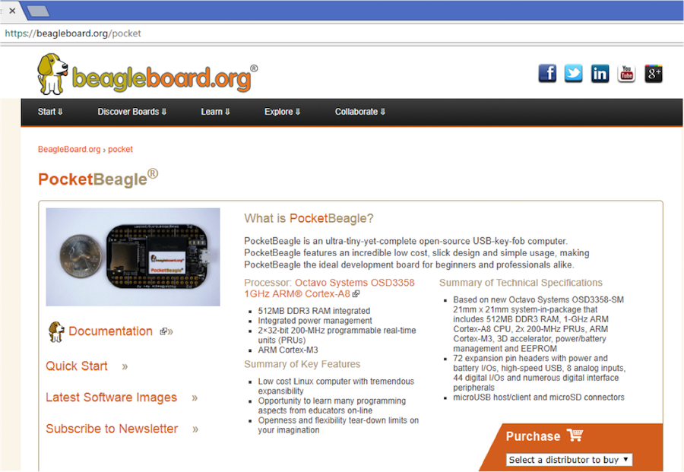
Make sure you check the support Wiki frequently for the most up to date information. github.com/beagleboard/pocketbeagle/wiki

2.0 Change History
This section describes the change history of this document and board. Document changes are not always a result of a board change. A board change will always result in a document change.

2.1 Document Change History

Table 1. Change History
Rev | Changes | Date | By
A.x | Production Document | December 7, 2017 | JK

2.2 Board Changes

Table 2. Board History
Rev | Changes | Date | By
A1 | Preliminary | February 14, 2017 | JK
A2 | Production. Fixed mikroBUS Click reset pins (made GPIO). | September 22, 2017 | JK

2.2.1 PocketBone
Upon the creation of the first, 27mm-by-27mm, Octavo Systems OSD3358 SIP, Jason did a hack two-layer board in EAGLE called “PocketBone” to drop the Beagle name as this was a totally unofficial effort not geared at being a BeagleBoard.org Foundation project. The board never worked because the 32kHz and 24MHz crystals were backwards and Michael Welling decided to pick it up and redo the design in KiCad as a four-layer board. Jason paid for some prototypes and this resulted in the first successful “PocketBone”, a fully-open-source 1-GHz Linux computer in a fitting into a mini-mint tin.

2.2.2 Rev A1
The Rev A1 of PocketBeagle was a prototype not released to production. A few lines were wrong to be able to control mikroBUS Click add-on board reset lines and they were adjusted.

2.2.3 Rev A2
The Rev A2 of PocketBeagle was released to production and at World MakerFaire 2017.
Known issues in rev A2:
Issue | Link
GPIO44 is incorrectly labelled as GPIO48 | github.com/beagleboard/pocketbeagle/issues/4

3.0 Connecting Up PocketBeagle
This section provides instructions on how to hook up your board. The most common scenario is tethering PocketBeagle to your PC for local development.

3.1 What’s In the Package
In the package you will find two items as shown in Figures 2 and 3.
- PocketBeagle
- Getting Started instruction card with link to the support URL.

Figure 2. PocketBeagle Package
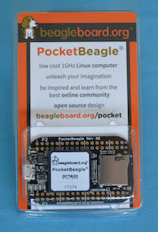

Figure 3. PocketBeagle Package Insert
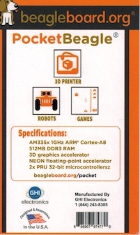

3.2 Connecting the board
This section will describe how to connect to the board. Information can also be found on the Quick Start Guide that came in the box. Detailed information is also available at beagleboard.org/getting-started
The board can be configured in several different ways, but we will discuss the most common scenario. Future revisions of this document may include additional configurations.

3.3 Tethered to a PC using Debian Images
In this configuration, you will need the following additional items:
- microUSB to USB Type A Cable
- microSD card (>=4GB and <128GB)
The board is powered by the PC via the USB cable, no other cables are required. The board is accessed either as a USB storage drive or via a web browser on the PC. You need to use either Firefox or Chrome on the PC, IE will not work properly. Figure 4 shows this configuration.

Figure 4. Tethered Configuration
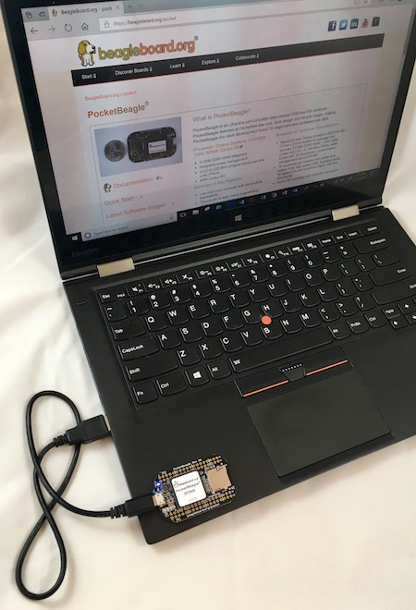
In some instances, such as when additional add-on boards, or PocketCapes are connected, the PC may not be able to supply sufficient power for the full system. In that case, review the power requirements for the add-on board/cape; additional power may need to be supplied via the 5v input, but rarely is this the case.

3.3.1 Getting Started
The following steps will guide you to quickly download a PocketBeagle software image onto your microSD card and get started writing code.
1. Navigate to the Getting Started Page beagleboard.org/getting-started Follow along with the instructions and click on the link noted in Figure 5 below beagleboard.org/latest-images. You can also get to this page directly by going to bbb.io/latest

Figure 5. Getting Started Page
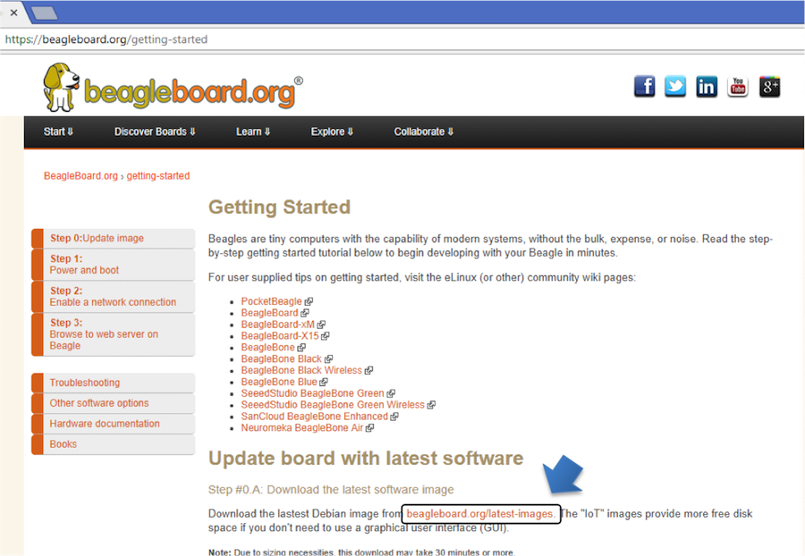
2. Download the latest image onto your computer by following the link to the latest image and click on the Debian image for Stretch IoT (non-GUI) for BeagleBone and PocketBeagle via microSD card. See Figure 6 below. This will download a .img.xz file into the downloads folder of your computer.

Figure 6. Download Latest Software Image
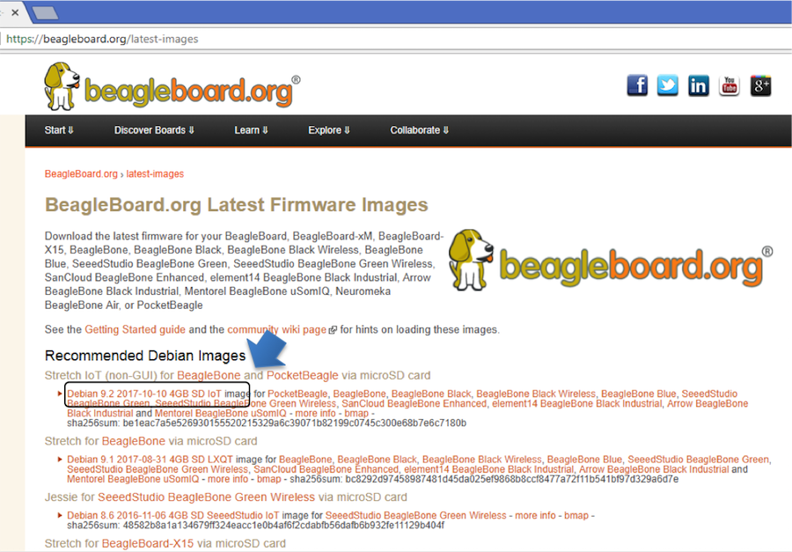
3. Transfer the image to a microSD card.
Download and install an SD card programming utility if you do not already have one. We like https://etcher.io/ for new users and so we show that one in the steps below. Go to your downloads folder and doubleclick on the .exe file and follow the on-screen prompts. See figure 7.

Figure 7. Download Etcher SD Card Utility
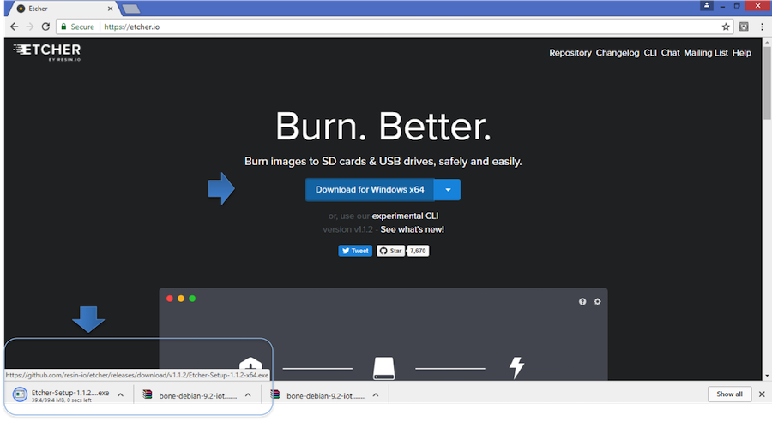
Insert a new microSD card into a card reader/writer and attach it via the USB connection to your computer. Follow the instructions on the screen for selecting the .img file and burning the image from your computer to the microSD card. Eject the SD card reader when prompted and remove the card. See Figures 8 and 9.

Figure 8. Select the PocketBeagle Image
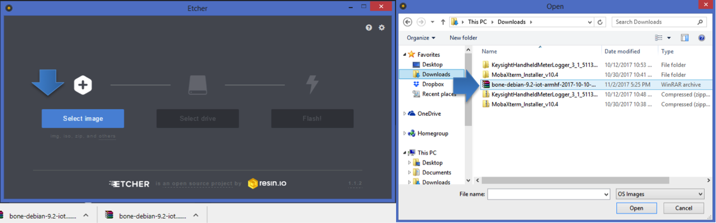

Figure 9. Burn the Image to the SD Card
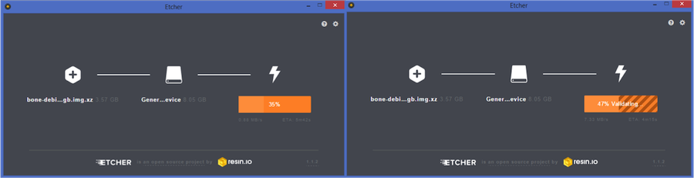
4. Insert the microSD card into the board - you'll hear a satisfying click when it seats properly into the slot. It is important that your microSD card is fully inserted prior to powering the system.

Figure 10. Insert the microSD Card into PocketBeagle
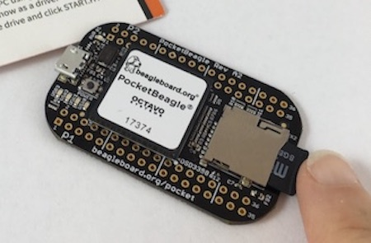
5. Connect the micro USB connector on your cable to the board as shown in Figure 11. The microUSB connector is fairly robust, but we suggest that you not use the cable as a leash for your PocketBeagle. Take proper care not to put too much stress on the connector or cable.

Figure 11. Insert the micro USB Connector into PocketBeagle
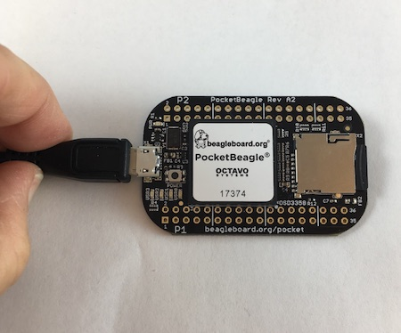
6. Connect the large connector of the USB cable to your Linux, Mac or Windows PC USB port as shown in Figure 12. The board will power on and the power LED will be on as shown in Figure 13 below.

Figure 12. Insert the USB connector into PC
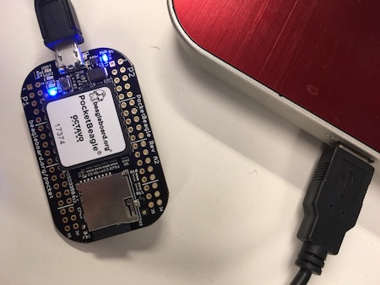

Figure 13. Board Power LED
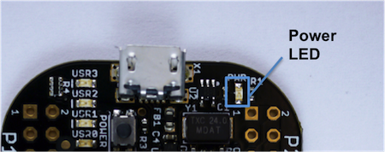
7. As soon as you apply power, the board will begin the booting process and the userLEDs Figure 14 will come on in sequence as shown below. It will take a few seconds for the status LEDs to come on, like teaching PocketBeagle to 'stay'. The LEDs will be flashing as it begins to boot the Linux kernel. While the four user LEDS can be over written and used as desired, they do have specific meanings in the image that you've initially placed on your microSD card once the Linux kernel has booted.
- USER0 is the heartbeat indicator from the Linux kernel.
- USER1 turns on when the microSD card is being accessed
- USER2 is an activity indicator. It turns on when the kernel is not in the idle loop.
- USER3 idle

Figure 14. User LEDs
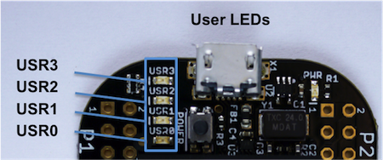

3.3.2 Accessing the Board and Getting Started with Coding
The board will appear as a USB Storage drive on your PC after the kernel has booted, which will take approximately 10 seconds. The kernel on the board needs to boot before the port gets enumerated. Once the board appears as a storage drive, do the following:
1. Open the USB Drive folder to view the files on your PocketBeagle.
2. Launch Interactive Quick Start Guide.
Right Click on the file named START.HTM and open it in Chrome or Firefox. This will use your browser to open a file running on PocketBeagle via the microSD card. You will see file:///Volumes/BEAGLEBONE/START.htm in the url bar of the browser. See Figure 15 below. This action displays an interactive Quick Start Guide from PocketBeagle.

Figure 15. Interactive Quick Start Guide Launch
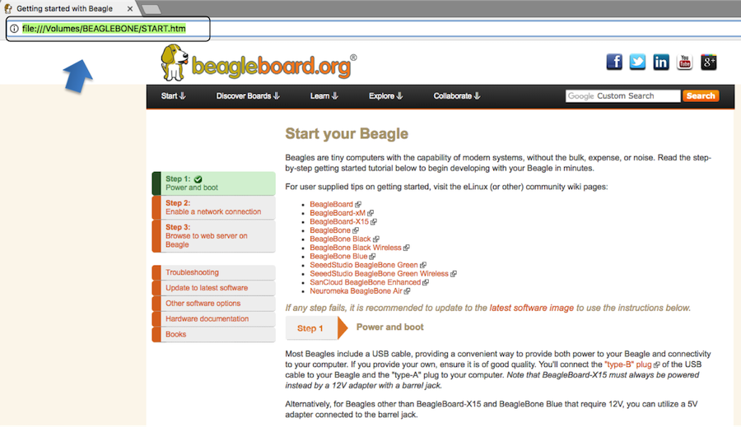
3. Enable a Network Connection.
Click on 'Step 2' of the Interactive Quick Start Guide page to follow instructions to "Enable a Network Connection" (pointing to the DHCP server that is running on PocketBeagle). Copy the appropriate IP Address from the chart (according to your PC operating system type) and paste into your browser then add a :3000 to the end of it. See example in Figure 16 below. This will launch from PocketBeagle one of it's favorite Web Based Development Environments, Cloud9 IDE, (Figure 17) so that you can teach your beagle new tricks!

Figure 16. Enable a Network Connection
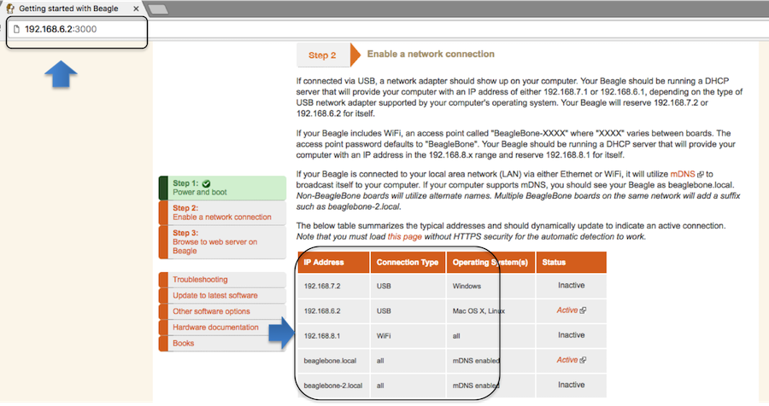

Figure 17. Launch Cloud9 IDE
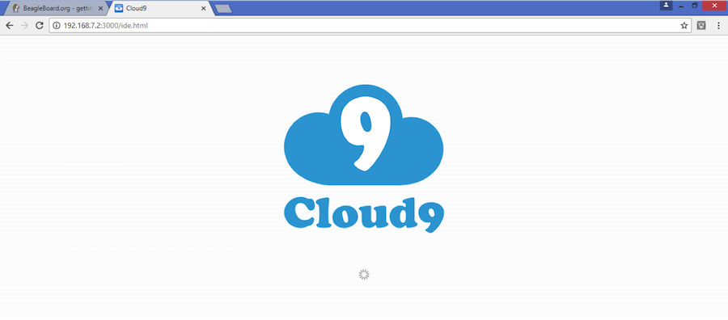
4. Get Started Coding with Cloud9 IDE - blinking USR3 LED in JavaScript using the BoneScript library example
- Create a new text file 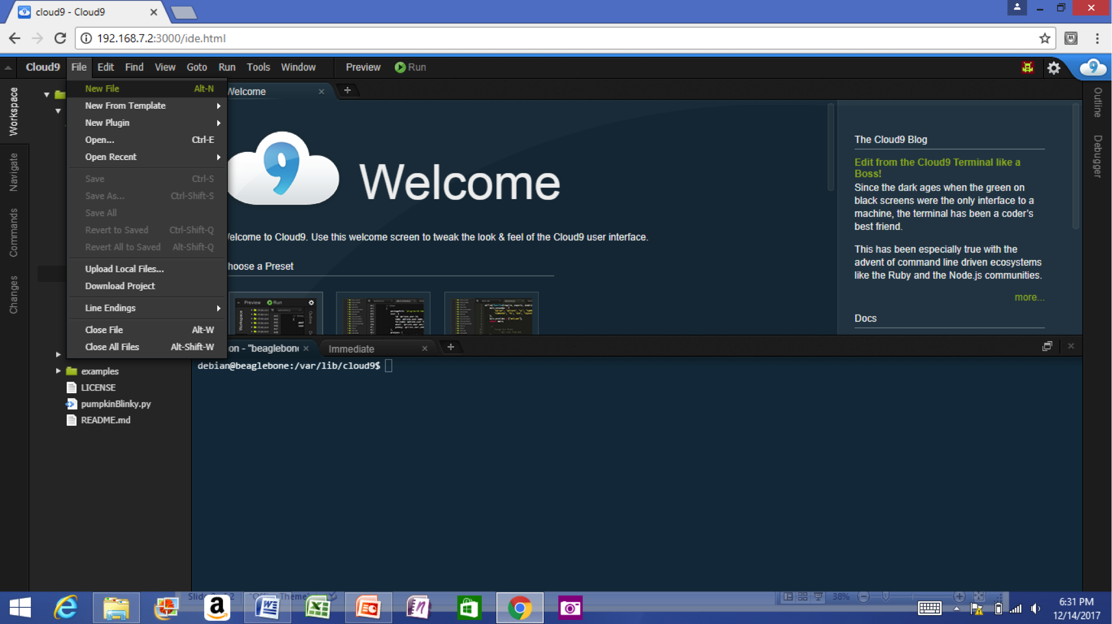
- Copy and paste the below code into the editor
var b = require('bonescript');
var state = b.LOW;
b.pinMode("USR3", b.OUTPUT);
setInterval(toggle, 250); // toggle 4 times a second, every 250ms
function toggle() {
if(state == b.LOW) state = b.HIGH;
else state = b.LOW;
b.digitalWrite("USR3", state);
}
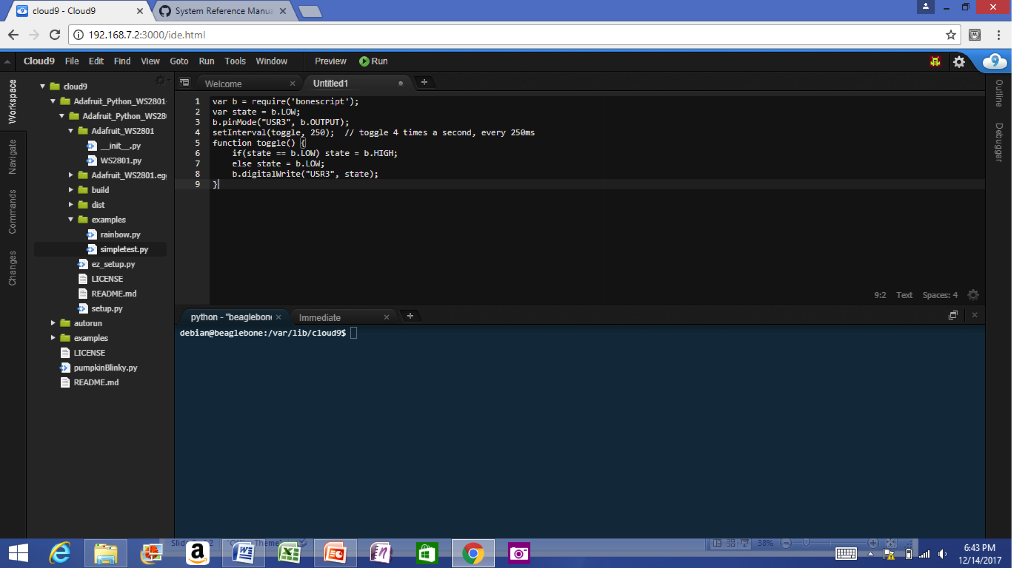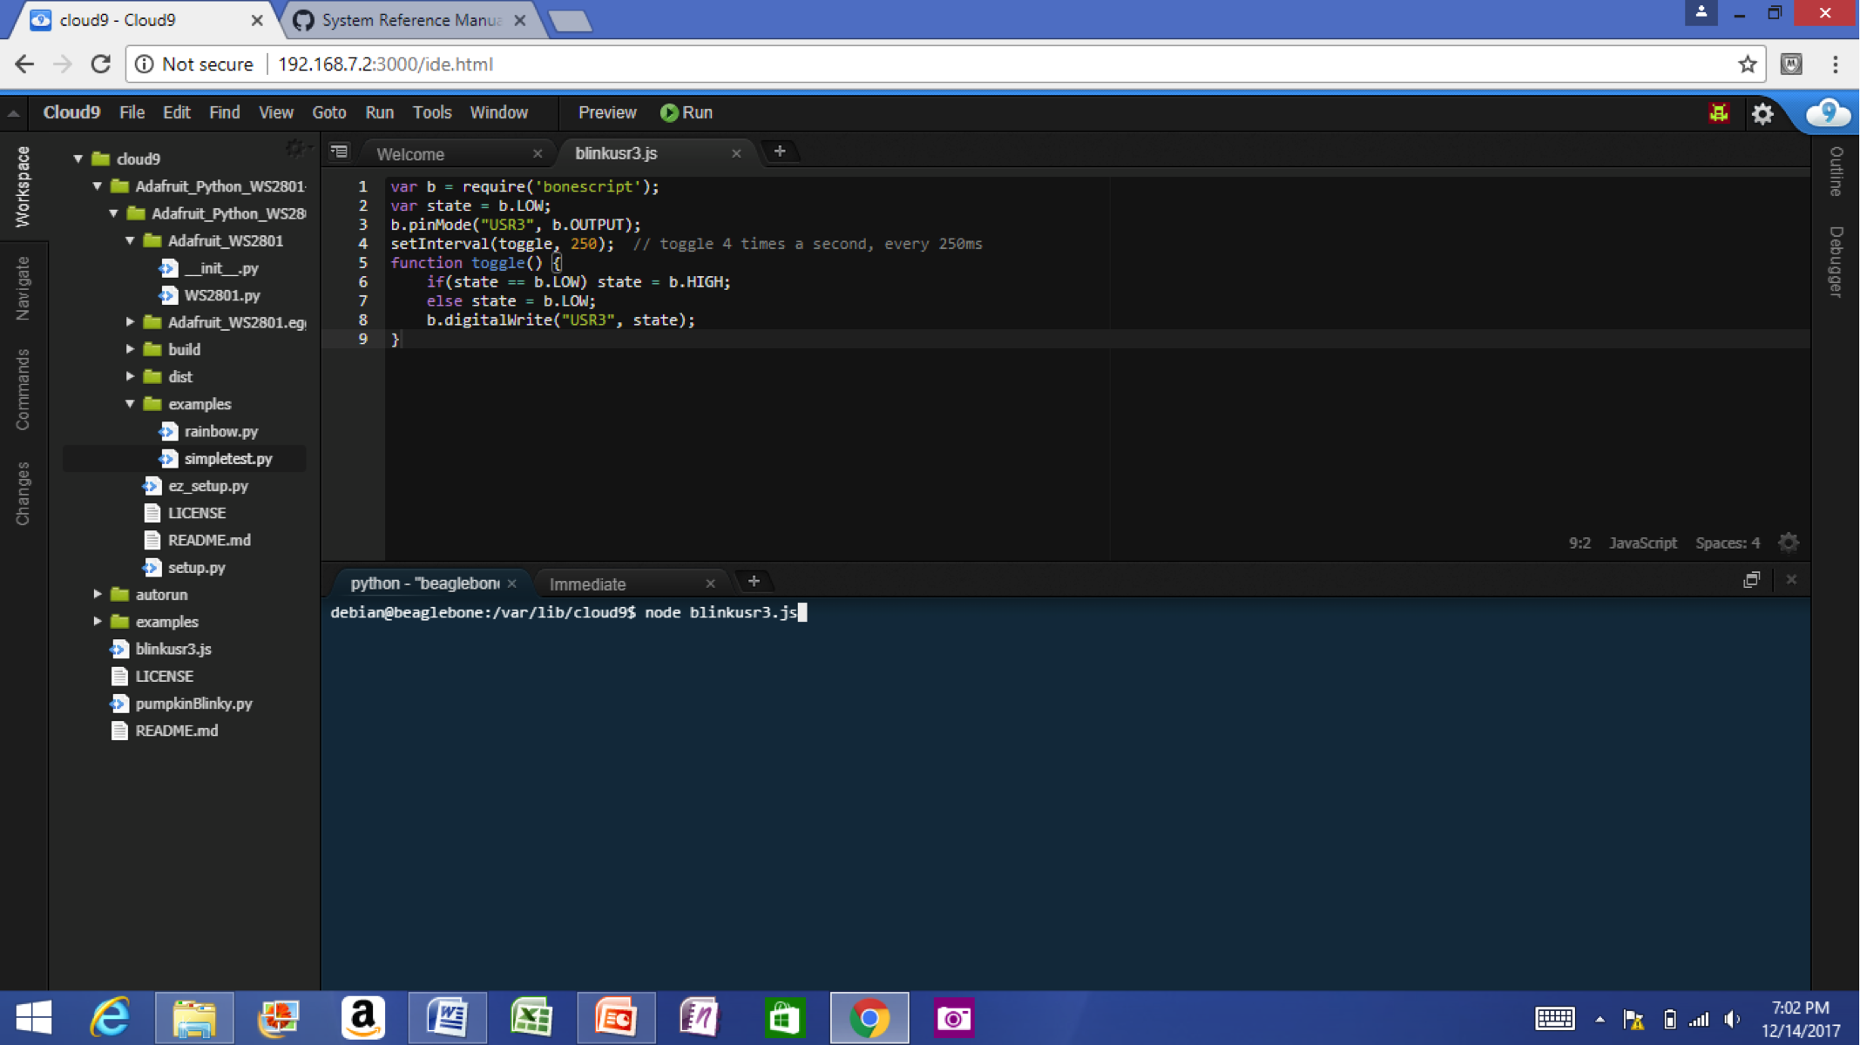
- Save the new text file as blinkusr3.js within the default directory
- Execute
node blinkusr3.js
within the default (/var/lib/cloud9) directory 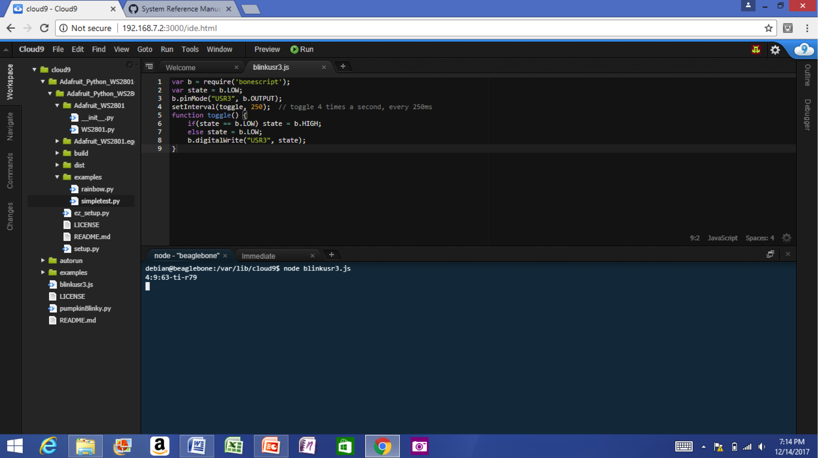
- Type CTRL+C to stop the program running

3.3.3 Powering Down
1. Standard Power Down Press the power button momentarily with a tap. The system will power down automatically. This will shut down your software with grace. Software routines will run to completion.
The Standard Power Down can also be invoked from the Linux command shell via "sudo shutdown -h now".
2. Hard Power Down Press the power button for 10 seconds. This will force an immediate shut down of the software. For example you may lose any items you have written to the memory. Holding the button longer than 10 seconds will perform a power reset and the system will power back on.
3. Remove the USB cable Remember to hold your board firmly at the USB connection while you remove the cable to prevent damage to the USB connector.
4. Powering up again. If you'd like to power up again without removing the USB cable follow these instructions:
- If you used Step 1 above to power down, to power back up, hold the power button for 10 seconds, release then tap it once and the system will boot normally.
- If you used Step 2 above to power down, to power back up, simply tap the power button and the system will boot normally.

Figure 20. Power Button
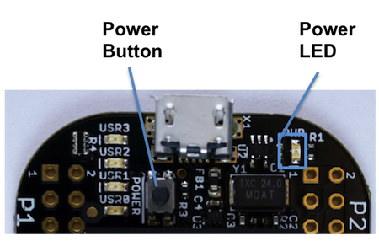

3.4 Other ways to Connect up to your PocketBeagle
The board can be configured in several different ways. Future revisions of this document may include additional configurations.
As other examples become documented, we'll update them on the Wiki for PocketBeagle github.com/beagleboard/pocketbeagle/wiki See also the on-line discussion.

4.0 PocketBeagle Overview
PocketBeagle is built around Octavo Systems' OSD335x-SM System-In-Package that integrates a high-performance Texas Instruments AM3358 processor, 512MB of DDR3, power management, nonvolatile serial memory and over 100 passive components into a single package. This integration saves board space by eliminating several packages that would otherwise need to be placed on the board, but more notably simplifies our board design so we can focus on the user experience.
The compact PocketBeagle design also offers access through the expansion headers to many of the interfaces and allows for the use of add-on boards called PocketCapes and Click Boards from MikroElektronika, to add many different combinations of features. A user may also develop their own board or add their own circuitry.

4.1 PocketBeagle Features and Specification
This section covers the specifications and features of the board in a chart and provides a high level description of the major components and interfaces that make up the board.

Table 3. PocketBeagle Features
Feature | '
System-In-Package | Octavo Systems OSD335x-SM in 256 Ball BGA (21mm x 21mm)
SiP Incorporates :
Processor | Texas Instruments 1GHz Sitara™ AM3358 ARM® Cortex®-A8 with NEON floating-point accelerator
Graphics Engine | Imagination Technologies PowerVR SGX530 Graphics Accelerator
Real-Time Units | 2x programmable real-time unit (PRU) 32-bit 200MHz microcontrollers with single-cycle I/O latency
Coprocessor | ARM® Cortex®-M3 for power management functions
SDRAM Memory | 512MB DDR3 800MHz RAM
Non-Volatile Memory | 4KB I2C EEPROM for board configuration information
Power Management | TPS65217C PMIC along with TL5209 LDO to provide power to the system with integrated 1-cell LiPo battery support
Connectivity :
SD/MMC | Bootable microSD card slot
USB | High speed USB 2.0 OTG (host/client) micro-B connector
Debug Support | JTAG test points and gdb/other monitor-mode debug possible
Power Source | microUSB connector, also expansion header options (battery, VIN or USB-VIN)
User I/O | Power Button with press detection interrupt via TPS65217C PMIC
Expansion Header :
USB | High speed USB 2.0 OTG (host/client) control signals
Analog Inputs | 8 analog inputs with 6 @ 1.8V and 2 @ 3.3V along with 1.8V references
Digital I/O | 44 digital GPIOs accessible with 18 enabled by default including 2 shared with the 3.3V analog input pins
UART | 3 UARTs accessible with 2 enabled by default
I2C | 2 I2C busses enabled by default
SPI | 2 SPI busses with single chip selects enabled by default
PWM | 4 Pulse Width Modulation outputs accessible with 2 enabled by default
QEP | 2 Quadrature encoder inputs accessible
CAN | 2 CAN bus controllers accessible

4.1.1 OSD3358-512M-BSM System in Package
The Octavo Systems OSD3358-512M-BSM System-In-Package (SiP) is part of a family of products that are building blocks designed to allow easy and cost-effective implementation of systems based in Texas Instruments powerful Sitara AM335x line of processors. The OSD335x-SM integrates the AM335x along with the TI TPS65217C PMIC, the TI TL5209 LDO, up to 1 GB of DDR3 Memory, a 4 KB EEPROM for non-volatile configuration storage and resistors, capacitors and inductors into a single 21mm x 21mm design-in-ready package.
With this level of integration, the OSD335x-SM family of SiPs allows designers to focus on the key aspects of their system without spending time on the complicated high-speed design of the processor/DDR3 interface or the PMIC power distribution. It reduces size and complexity of design.
Full Datasheet and more information is available at octavosystems.com/octavo_products/osd335x-sm/

4.2 Board Component Locations
This section describes the key components on the board, their location and function.
Figure 21 below shows the locations of the devices, connectors, LEDs, and switches on the PCB layout of the board.

Figure 21. Key Board Component Locations
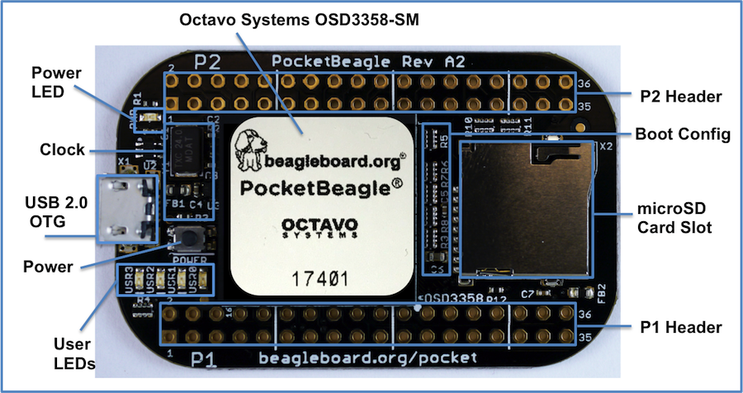
Key Components
- The Octavo Systems OSD3358-512M-BSM System-In-Package is the processor system for the board
- P1 and P2 Headers come unpopulated so a user may choose their orientation
- User LEDs provides 4 programmable blue LEDs
- Power BUTTON can be used to power up or power down the board (see section 3.3.3 for details)
- USB 2.0 OTG is a microUSB connection to a PC that can also power the board
- Power LED provides communication regarding the power to the board
- microSD slot is where a microSD card can be installed.

5.0 PocketBeagle High Level Specification
This section provides the high level specification of PocketBeagle.

5.1 Block Diagram
Figure 22 below is the high level block diagram of PocketBeagle.

Figure 22. PocketBeagle Key Components
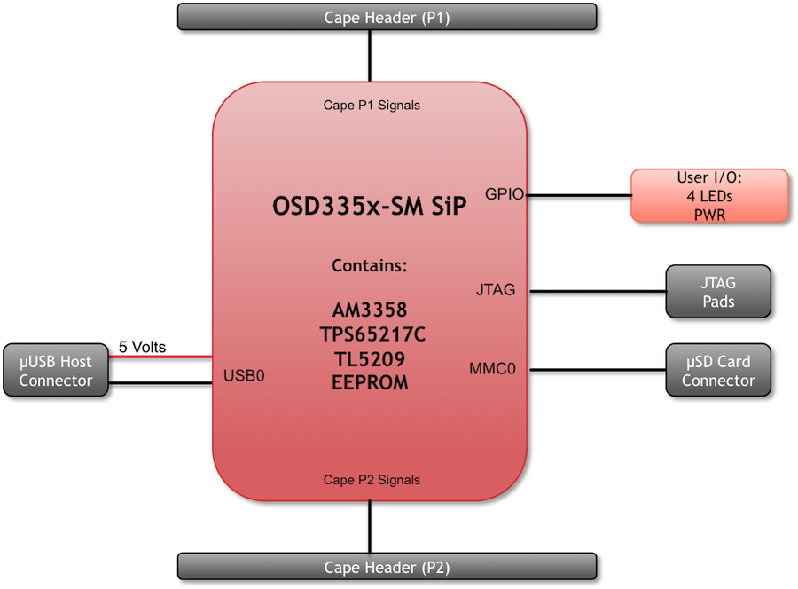

5.2 System in Package (SiP)
The OSD335x-SM Block Diagram is detailed in Figure 23 below. More information, including design resources are available on the 'Octavo Systems Website'

Figure 23. OSD335x SIP Block Diagram
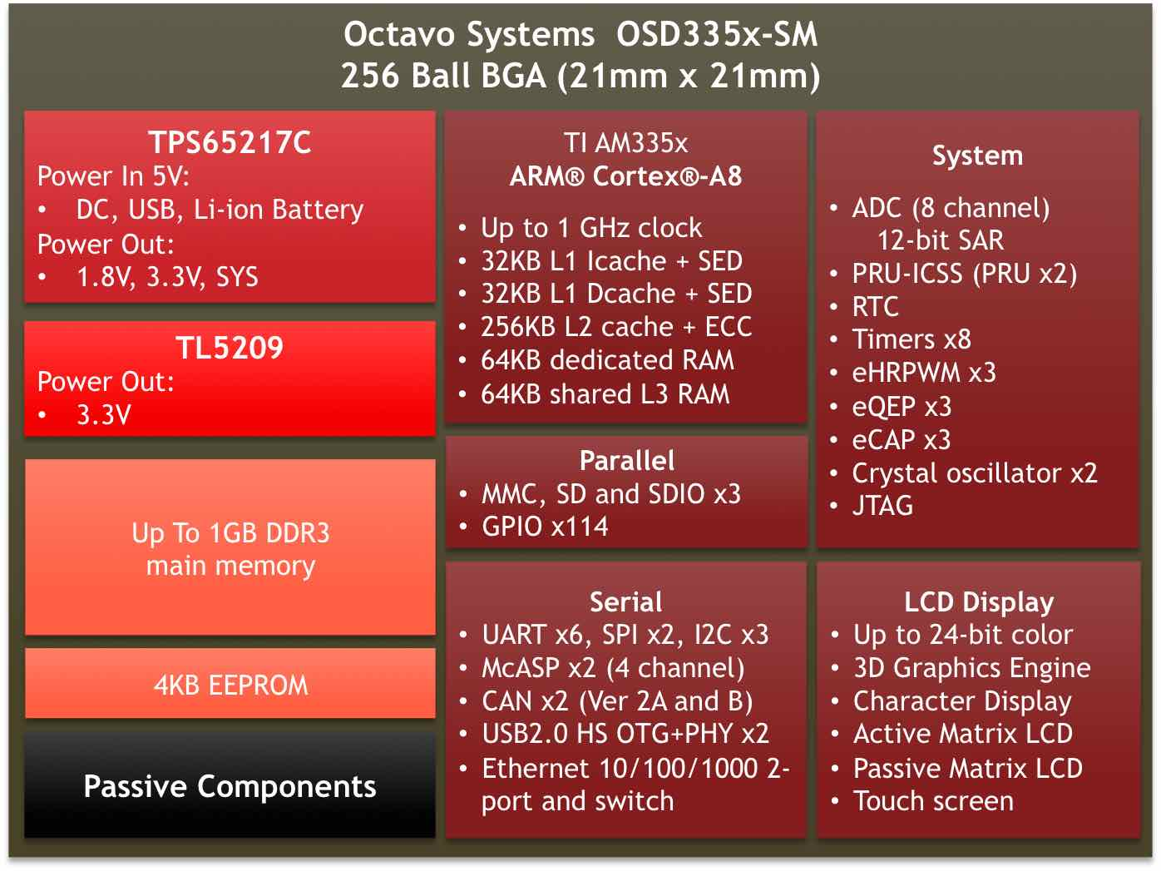
Note: PocketBeagle utilizes the 512MB DDR3 memory size version of the OSD335x-SM A few of the features of the OSD335x-SM SiP may not be available on PocketBeagle headers. Please check Section 7 for the P1 and P2 header pin tables.

5.3 Connectivity

5.3.1 Expansion Headers
PocketBeagle gives access to a large number of peripheral functions and GPIO via 2 dual rail expansion headers. With 36 pins each, the headers have been left unpopulated to enable users to choose the header connector orientation or add-on board / cape connector style. Pins are clearly marked on the bottom of the board with additional pin configurations available through software settings. Detailed information is available in Section 7.

Figure 24. PocketBeagle Expansion Headers
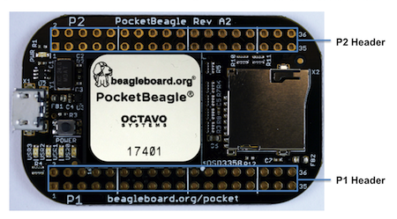

5.3.2 microSD Connector
The board is equipped with a single microSD connector to act as the primary boot source for the board. Just about any microSD card you have will work, we commonly find 4G to be suitable.
When plugging in the SD card, the writing on the card should be up. Align the card with the connector and push to insert. Then release. There should be a click and the card will start to eject slightly, but it then should latch into the connector. To eject the card, push the SD card in and then remove your finger. The SD card will be ejected from the connector. Do not pull the SD card out or you could damage the connector.

Figure 25. microSD Connector
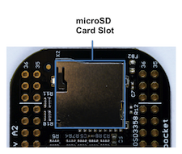

5.3.3 USB 2.0 Connector
The board has a microUSB connector that is USB 2.0 HS compatible that connects the USB0 port to the SiP. Generally this port is used as a client USB port connected to a power source, such as your PC, to power the board. If you would like to use this port in host mode you will need to supply power for peripherals via Header P1 pin 7 (USB1.VIN) or through a powered USB Hub. Additionally, in the USB host configuration, you will need to power the board through Header P1 pin 1 (VIN) or Header P1 pin 7 (USB1.VIN) or Header P2 pin 14 (BAT.VIN)

Figure 26. USB 2.0 Connector
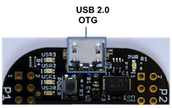

5.3.4 Boot Modes
There are three boot modes:
- SD Boot: MicroSD connector acts as the primary boot source for the board. This is described in Section 3.
- USB Boot: This mode supports booting over the USB port. More information can be found in the project called "BeagleBoot" This project ported the BeagleBone bootloader server BBBlfs(currently written in c) to JavaScript(node.js) and make a cross platform GUI (using electron framework) flashing tool utilizing the etcher.io project. This will allow a single code base for a cross platform tool. For more information on BeagleBoot, see the BeagleBoot Project Page.
- Serial Boot: This mode will use the serial port to allow downloading of the software. A separate USB to TTL level serial UART converter cable is required or you can connect one of the Mikroelektronika FTDI Click Boards to use this method. The UART pins on PocketBeagle's expansion headers support the interface. For more information regarding the pins on the expansion headers and various modes, see Section 7.

Table 4. UART Pins on Expansion Headers for Serial Boot
Header.Pin | Silkscreen | Proc Ball | SiP Ball | Pin Name (Mode 0)
P1.22 | GND |  |  | GND
P1.30 | U0_TX | E16 | B12 | uart0_txd
P1.32 | U0_RX | E15 | A12 | uart0_rxd
If the Serial Boot is not in use, the UART0 pins can be used for Serial Debug. See Section 5.6 for more information.
Software to support USB and serial boot modes is not provided by beagleboard.org. Please contact TI for support of this feature.

5.4 Power
The board can be powered from three different sources:
- A USB port on a PC.
- A power supply with a USB connector.
- Expansion Header pins.
Note: VIN-USB is directly shorted between the USB connector on PocketBeagle and USB1_VI on the expansion headers. You should only source power to the board over one of these and may optionally use the other as a power sink.
The tables below show the power related pins available on PocketBeagle's Expansion Headers.

Table 5. Power Inputs Available on Expansion Headers
Header.Pin | Silkscreen | Proc Ball | SiP Ball | Pin Name (Mode 0)
P1.01 | VIN |  | P10, R10, T10 | VIN
P1.07 | USB1_VI |  | P9, R9, T9 | VIN-USB
P2.14 | BAT_+ |  | P8, R8, T8 | VIN-BAT

Table 6. Power Outputs Available on Expansion Headers
Header.Pin | Silkscreen | Proc Ball | SiP Ball | Pin Name (Mode 0)
P1.14 | +3.3V |  | F6, F7, G6, G7 | VOUT-3.3V
P1.24 | VOUT |  | K6, K7, L6, L7 | VOUT-5V
P2.13 | VOUT |  | K6, K7, L6, L7 | VOUT-5V
P2.23 | +3.3V |  | F6, F7, G6, G7 | VOUT-3.3V

Table 5. Ground Pins Available on Expansion Headers
Header.Pin | Silkscreen | Proc Ball | SiP Ball | Pin Name (Mode 0)
P1.15 | USB1_GND |  |  | GND
P1.16 | GND |  |  | GND
P1.22 | GND |  |  | GND
P2.15 | GND |  |  | GND
P2.21 | GND |  |  | GND
Note: A comprehensive tutorial for Power Inputs and Outputs for the OSD335x System in Package is available in the 'Tutorial Series' on the Octavo Systems website.

5.5 JTAG Pads
Pads for an optional connection to a JTAG emulator has been provided on the back of PocketBeagle. More information about JTAG emulation can be found on the TI website - 'Entry-level debug through full-capability development'

Figure 27. JTAG Pad Connections
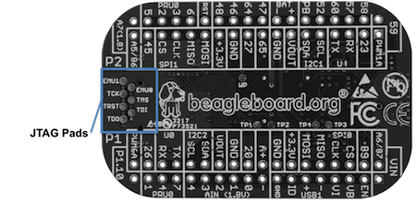

5.6 Serial Debug Port
Serial debug is provided via UART0 on the processor. See Section 5.3.4 for the Header Pin table. Signals supported are TX and RX. None of the handshake signals (CTS/RTS) are supported. A separate USB to TTL level serial UART converter cable is required or you can connect one of the Mikroelektronika FTDI Click Boardsto use this method.

Figure 28. Serial Debug Connections
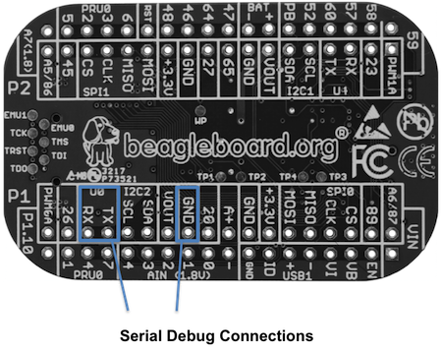
If serial boot is not used, the UART0 can be used to view boot messages during startup and can provide access to a console using a terminal access program like Putty. To view the boot messages or use the console the UART should be set to a baud rate of 115200 and use 8 bits for data, no parity bit and 1 stop bit (8N1).

6.0 Detailed Hardware Design
The following sections contain schematic references for PocketBeagle. Full schematics in both PDF and Eagle are available on the 'PocketBeagle Wiki'

6.1 OSD3358-SM SiP Design
Schematics for the OSD3358-SM SiP are divided into several diagrams.

6.1.1 SiP A OSD3358 SiP System and Power Signals

Figure 29. SiP A OSD3358 SiP System and Power Signals
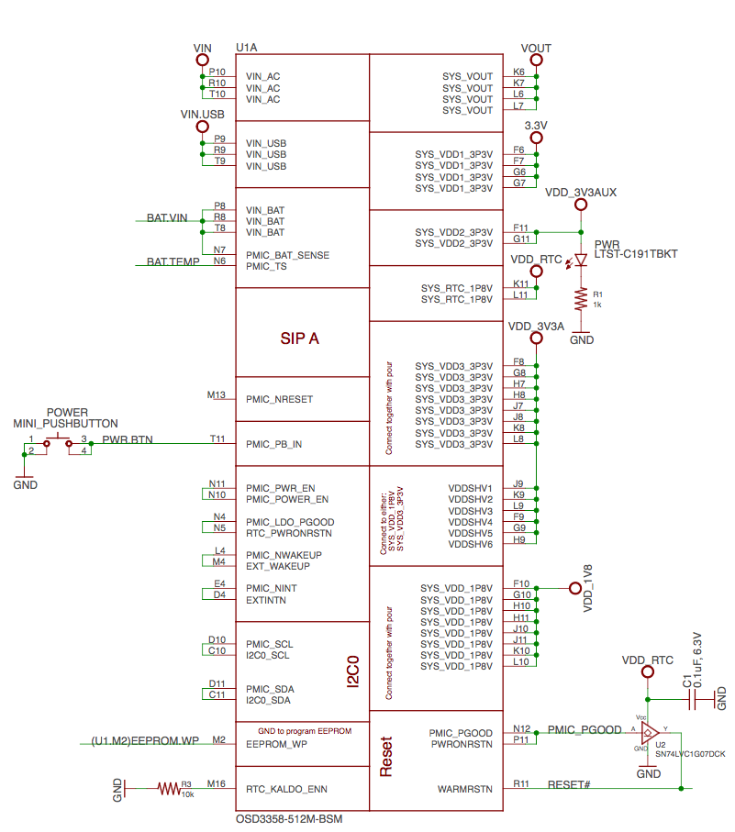

6.1.2 SiP B OSD3358 SiP JTAG, USB & Analog Signals

Figure 30. SiP B OSD3358 SiP JTAG, USB & Analog Signals
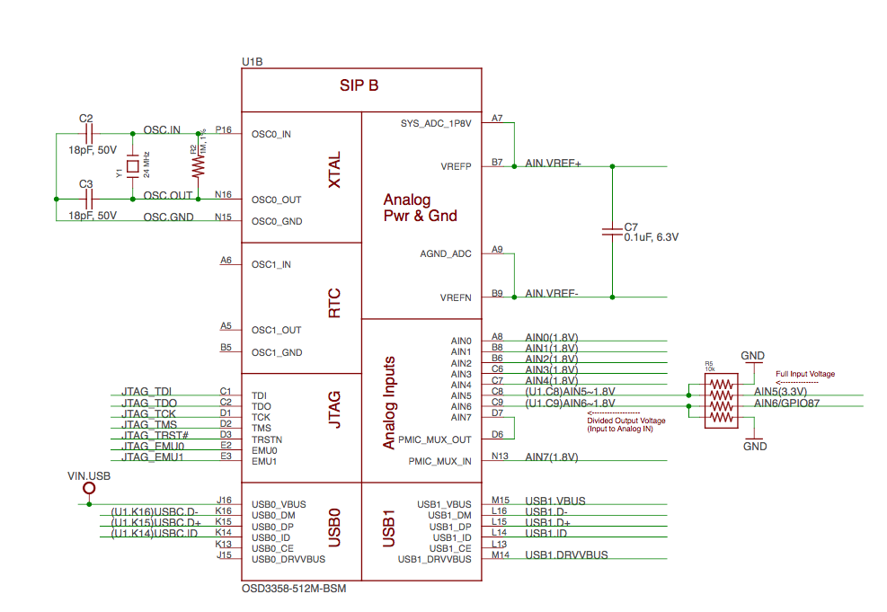

6.1.3 SiP C OSD3358 SiP Peripheral Signals

Figure 31. SiP C OSD3358 SiP Peripheral Signals
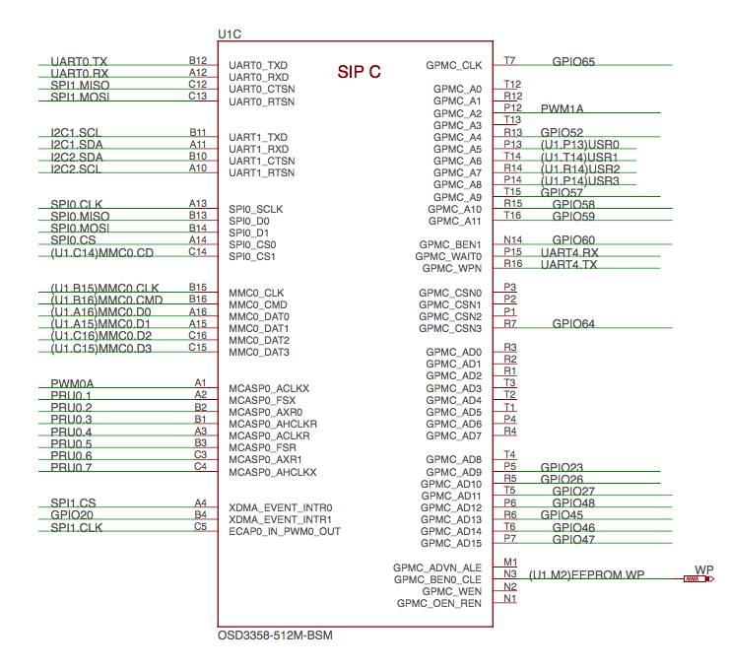

6.1.4 SiP D OSD3358 SiP System Boot Configuration

Figure 32. SiP D OSD3358 SiP System Boot Configuration
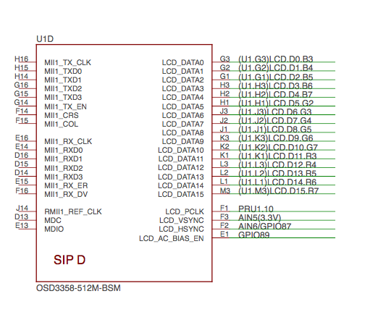

6.1.5 SiP E OSD3358 SiP Power Signals

Figure 33. SiP E OSD3358 SiP Power Signals
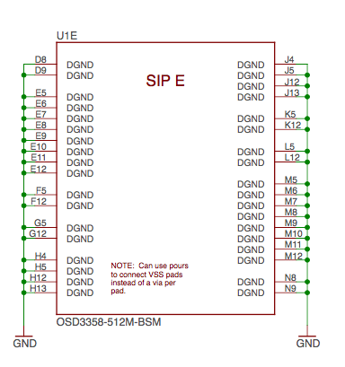

6.1.6 SiP F OSD3358 SiP Power Signals

Figure 34. SiP F OSD3358 SiP Power Signals
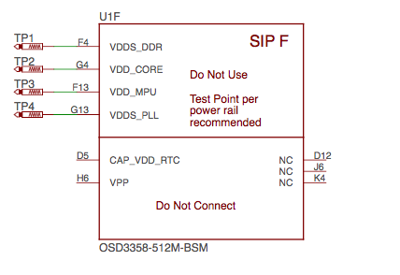

6.2 MicroSD Connection
The Micro Secure Digital (microSD) connector design is highlighted in Figure 35.

Figure 35. microSD Connections
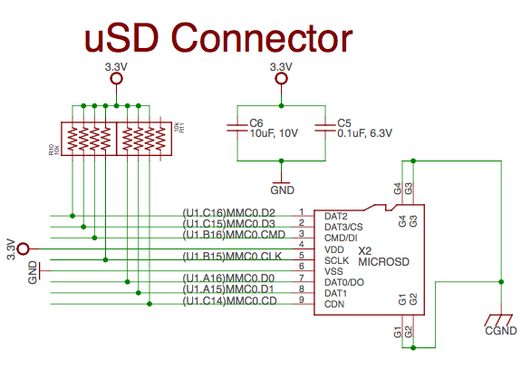

6.3 USB Connector
The USB connector design is highlighted in Figure 36.
Note that there is an ID pin for dual-role (host/client) functionality. The hardware fully supports it, but care should be taken to ensure the kernel in use is either statically or dynamically configured to recognize and utilize the proper mode.

Figure 36. USB Connection
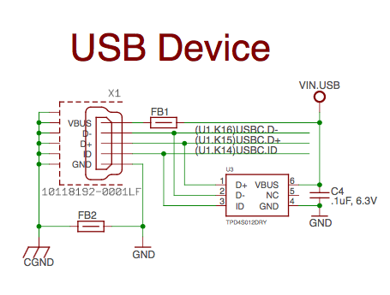

6.4 Power Button Design
The power button design is highlighted in Figure 37.

Figure 37. Power Button
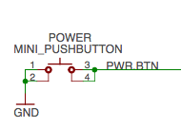

6.5 User LEDs
There are four user programmable LEDs on PocketBeagle. The design is highlighted in Figure 38. Table 6 Provides the LED control signals and pins. A logic level of "1" will cause the LEDs to turn on.

Figure 38. User LEDs
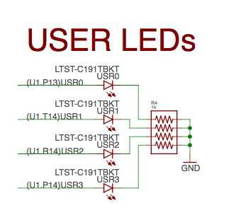

Table 6. User LED Control Signals/Pins
LED | Signal Name | Proc Ball | SiP Ball
USR0 | GPIO1_21 | V15 | P13
USR1 | GPIO1_22 | U15 | T14
USR2 | GPIO1_23 | T15 | R14
USR3 | GPIO1_24 | V16 | P14

6.6 JTAG Pads
There are 7 pads on the bottom of PocketBeagle to connect JTAG for debugging. The design is highlighted in Figure 39. More information regarding JTAG debugging can be found at 'www.ti.com/jtag'

Figure 39. JTAG Pads Design
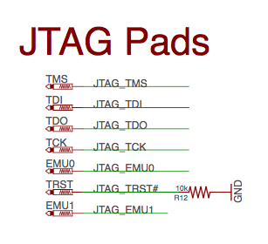

6.7 PRU-ICSS
The Programmable Real-Time Unit Subsystem and Industrial Communication SubSystem (PRU-ICSS) module is located inside the AM3358 processor, which is inside the Octavo Systems SiP. Commonly referred to as just the "PRU", this little subsystem will unleash a lot of performance for you to use in your application. Consisting of dual 32-bit RISC cores (Programmable Real-Time Units, or PRUs), data and instruction memories, internal peripheral modules, and an interrupt controller (INTC). The programmable nature of the PRU-ICSS, along with their access to pins, events and all SoC resources, provides flexibility in implementing fast real-time responses, specialized data handling operations, custom peripheral interfaces, and in offloading tasks from the other processor cores of the system-on-chip (SoC). Access to these pins is provided by PocketBeagle's expansion headers and is multiplexed with other functions on the board. Access is not provided to all of the available pins.
Some getting started information can be found on https://beagleboard.org/pru.
Additional documentation is located on the Texas Instruments website at processors.wiki.ti.com/index.php/PRU-ICSS and also located at http://github.com/beagleboard/am335x_pru_package.
Example projects using the PRU-ICSS can be found at processors.wiki.ti.com/index.php/PRU_Projects.

6.7.1 PRU-ICSS Features
The features of the PRU-ICSS include:
Two independent programmable real-time (PRU) cores:
- 32-Bit Load/Store RISC architecture
- 8K Byte instruction RAM (2K instructions) per core
- 8K Bytes data RAM per core
- 12K Bytes shared RAM
- Operating frequency of 200 MHz
- PRU operation is little endian similar to ARM processor
- All memories within PRU-ICSS support parity
- Includes Interrupt Controller for system event handling
- Fast I/O interface
– 16 input pins and 16 output pins per PRU core. (Not all of these are accessible on the PocketBeagle. Please check the Pin Table below for PRU-ICSS features available through the P1 and P2 headers.)

6.7.2 PRU-ICSS Block Diagram
Figure 40 is a high level block diagram of the PRU-ICSS.
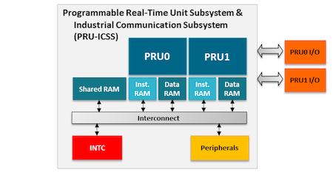

Figure 40. PRU-ICSS Block Diagram

6.7.3 PRU-ICSS Pin Access
Both PRU 0 and PRU1 are accessible from the expansion headers. Listed below are the ports that can be accessed on each PRU.
Table 6. below shows which PRU-ICSS signals can be accessed on PocketBeagle and on which connector and pins on which they are accessible. Some signals are accessible on the same pins.

Table 6. PRU0 and PRU1 Access
Use scroll bar at bottom of chart to see additional features in columns to the right. When printing this document, you will need to print this chart separately.
Header.Pin | Silkscreen | Processor Ball | SiP Ball | Mode3 | Mode4 | Mode5 | Mode6 | Note
P1.02 | A6/87 | R5 | F2 |  |  | pr1_pru1_pru_r30_9 (Output) | pr1_pru1_pru_r31_9 (Input)
P1.04 | 89 | R6 | E1 |  |  | pr1_pru1_pru_r30_11 (Output) | pr1_pru1_pru_r31_11 (Input)
P1.06 | SPI0_CS | A16 | A14 |  | pr1_uart0_txd (Output) |  |  | UART Transmit Data
P1.08 | SPI0_CLK | A17 | A13 |  | pr1_uart0_cts_n (Input) |  |  | UART Clear to Send
P1.10 | SPI0_MISO | B17 | B13 |  | pr1_uart0_rts_n (Output) |  |  | UART Request to Send
P1.12 | SPI0_MOSI | B16 | B14 |  | pr1_uart0_rxd (Input) |  |  | UART Receive Data
P1.20 | 20 | D14 | B4 |  |  | pr1_pru0_pru_r31_16 (Input)
P1.26 | I2C2_SDA | D18 | B10 |  |  | pr1_uart0_cts_n (Input) |  | UART Clear to Send
P1.28 | I2C2_SCL | D17 | A10 |  |  | pr1_uart0_rts_n (Output) |  | UART Request to Send
P1.29 | PRU0_7 | A14 | C4 |  |  | pr1_pru0_pru_r30_7 (Output) | pr1_pru0_pru_r31_7 (Input)
P1.30 | U0_TX | E16 | B12 |  |  | pr1_pru1_pru_r30_15 (Output) | pr1_pru1_pru_r31_15 (Input)
P1.31 | PRU0_4 | B12 | A3 |  |  | pr1_pru0_pru_r30_4 (Output) | pr1_pru0_pru_r31_4 (Input)
P1.32 | U0_RX | E15 | A12 |  |  | pr1_pru1_pru_r30_14 (Output) | pr1_pru1_pru_r31_14 (Input)
P1.33 | PRU0_1 | B13 | A2 |  |  | pr1_pru0_pru_r30_1 (Output) | pr1_pru0_pru_r31_1 (Input)
P1.35 | P1.10 | V5 | F1 |  |  | pr1_pru1_pru_r30_10 (Output) | pr1_pru1_pru_r31_10 (Input)
P1.36 | PWM0A | A13 | A1 |  |  | pr1_pru0_pru_r30_0 (Output) | pr1_pru0_pru_r31_0 (Input)
P2.09 | I2C1_SCL | D15 | B11 |  |  | pr1_uart0_txd (Output) | pr1_pru0_pru_r31_16 (Input) | UART Transmit Data
P2.11 | I2C1_SDA | D16 | A11 |  |  | pr1_uart0_rxd (Input) | pr1_pru1_pru_r31_16 (Input) | UART Receive Data
P2.17 | 65 | V12 | T7 |  |  | pr1_mdio_mdclk |  | MDIO Clk
P2.18 | 47 | U13 | P7 |  |  | pr1_ecap0_ecap_capin_apwm_o | pr1_pru0_pru_r31_15 (Input) | Enhanced capture input or Auxiliary PWM out
P2.20 | 64 | T13 | R7 |  |  | pr1_mdio_data |  | MDIO Data
P2.22 | 46 | V13 | T6 |  |  |  | pr1_pru0_pru_r31_14 (Input)
P2.24 | 48 | T12 | P6 |  |  |  | pr1_pru0_pru_r30_14 (Output)
P2.28 | PRU0_6 | D13 | C3 |  |  | pr1_pru0_pru_r30_6 Output) | pr1_pru0_pru_r31_6 (Input)
P2.29 | SPI1_CLK | C18 | C5 | pr1_ecap0_ecap_capin_apwm_o |  |  |  | Enhanced capture input or Auxiliary PWM out
P2.30 | PRU0_3 | C12 | B1 |  |  | pr1_pru0_pru_r30_3 (Output) | pr1_pru0_pru_r31_3 (Input)
P2.31 | SPI1_CS | A15 | A4 |  |  | pr1_pru1_pru_r31_16 (Input)
P2.32 | PRU0_2 | D12 | B2 |  |  | pr1_pru0_pru_r30_2 (Output) | pr1_pru0_pru_r31_2 (Input)
P2.33 | 45 | R12 | R6 |  |  |  | pr1_pru0_pru_r30_15 (Output)
P2.34 | PRU0_5 | C13 | B3 |  |  | pr1_pru0_pru_r30_5 (Output) | pr1_pru0_pru_r31_5 (Input)
P2.35 | A5/86 | U5 | F3 |  |  | pr1_pru1_pru_r30_8 (Output) | pr1_pru1_pru_r31_8 (Input)

7.0 Connectors
This section describes each of the connectors on the board.

7.1 Expansion Header Connectors
The expansion interface on the board is comprised of two 36 pin connectors. The two Expansion Header Connectors on PocketBeagle are labeled P1 and P2. The connections are a standard 100 mil distance so that they can be compatible with many standard expansion items. The silkscreen for the headers on the bottom of the board provides the easiest way to identify them. See Figure 41.

Figure 41. Expansion Headers for PocketBeagle
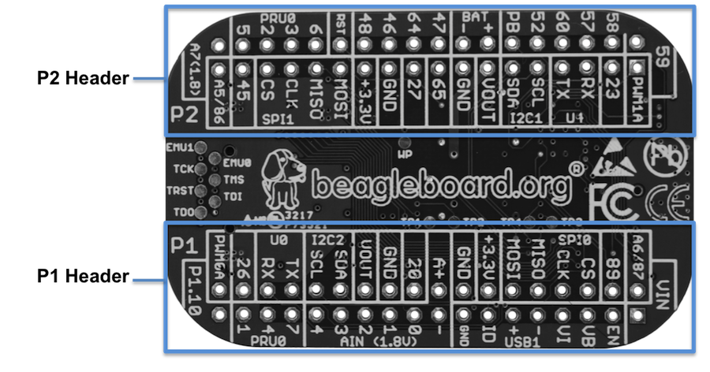
All signals on the expansion headers are 3.3V unless otherwise indicated.
NOTE: Do not connect 5V logic level signals to these pins or the board will be damaged.
NOTE: DO NOT APPLY VOLTAGE TO ANY I/O PIN WHEN POWER IS NOT SUPPLIED TO THE BOARD. IT WILL DAMAGE THE PROCESSOR AND VOID THE WARRANTY.
NO PINS ARE TO BE DRIVEN UNTIL AFTER THE SYS_RESET LINE GOES HIGH.
Figure 42 shows a color coded chart with an overview of the most popular functions of PocketBeagle's Expansion Header pins. The Header Pin tables in Sections 7.1.1 and 7.1.2 show the full pin assignments for each header.

Figure 42. Expansion Header Popular Functions - Color Coded
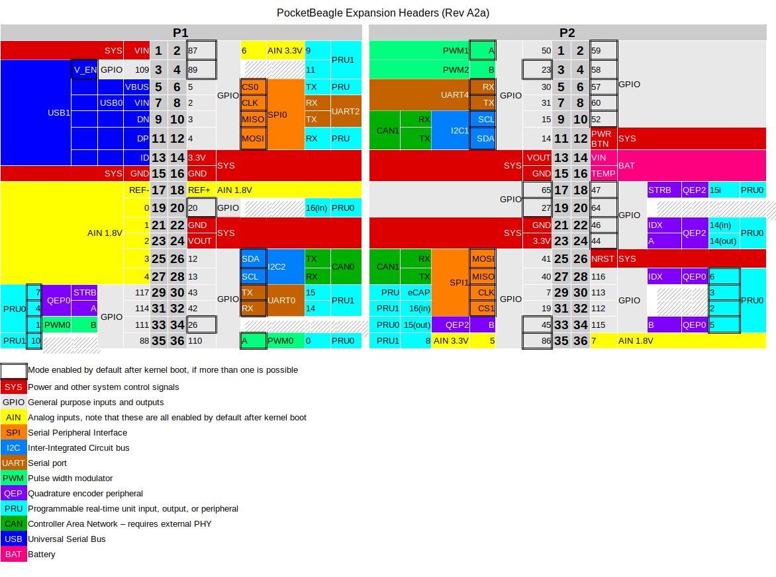

7.1.1 P1 Header
Figure 43 shows the schematic diagram for the P1 Header.

Figure 43 P1 Header
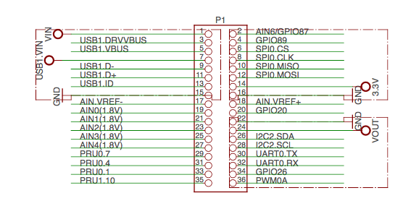

Table 7. P1 Header Pinout
Use scroll bar at bottom of chart to see additional features in columns to the right. When printing this document you will need to print this chart separately.
Header.Pin | Silkscreen | PocketBeagle wiring | Proc Ball | SiP Ball | Mode0 (Name) | Mode1 | Mode2 | Mode3 | Mode4 | Mode5 | Mode6 | Mode7
P1.01 | VIN | P1.01 (VIN) |  | P10 & R10 & T10 | VIN
P1.02 | A6/87 | P1.02 (AIN6/GPIO87) | A8 | C9 | ain6
P1.02 | A6/87 | P1.02 (AIN6/GPIO87) | R5 | F2 | lcd_hsync | gpmc_a9 | gpmc_a2 | pr1_edio_data_in3 | pr1_edio_data_out3 | pr1_pru1_pru_r30_9 | pr1_pru1_pru_r31_9 | gpio2_23
P1.03 | USB1_EN | P1.03 (USB1-DRVVBUS) | F15 | M14 | USB1_DRVVBUS | - | - | - | - | - | - | gpio3_13
P1.04 | 89 | P1.04 (PRU1.11) | R6 | E1 | lcd_ac_bias_en | gpmc_a11 | pr1_mii1_crs | pr1_edio_data_in5 | pr1_edio_data_out5 | pr1_pru1_pru_r30_11 | pr1_pru1_pru_r31_11 | gpio2_25
P1.05 | USB1_VB | P1.05 (USB1-VBUS) | T18 | M15 | USB1_VBUS | - | - | - | - | - | - | -
P1.06 | SPI0_CS | P1.06 (SPI0-CS) | A16 | A14 | spi0_cs0 | mmc2_sdwp | I2C1_SCL | ehrpwm0_synci | pr1_uart0_txd | pr1_edio_data_in1 | pr1_edio_data_out1 | gpio0_5
P1.07 | USB1_VI | P1.07 (VIN-USB) |  | P9 &R9 &T9 | VIN-USB
P1.08 | SPI0_CLK | P1.08 (SPI0-CLK) | A17 | A13 | spi0_sclk | uart2_rxd | I2C2_SDA | ehrpwm0A | pr1_uart0_cts_n | pr1_edio_sof | EMU2 | gpio0_02
P1.09 | USB1 - | P1.09 (USB1-DN) | R18 | L16 | USB1_DM | - | - | - | - | - | - | -
P1.10 | SPI0_MISO | P1.10 (SPI0-MISO) | B17 | B13 | spi0_d0 | uart2_txd | I2C2_SCL | ehrpwm0B | pr1_uart0_rts_n | pr1_edio_latch_in | EMU3 | gpio0_3
P1.11 | USB1 + | P1.11 (USB1-DP) | R17 | L15 | USB1_DP | - | - | - | - | - | - | -
P1.12 | SPI0_MOSI | P1.12 (SPI0-MOSI) | B16 | B14 | spi0_d1 | mmc1_sdwp | I2C1_SDA | ehrpwm0_tripzone_input | pr1_uart0_rxd | pr1_edio_data_in0 | pr1_edio_data_out0 | gpio0_04
P1.13 | USB1_ID | P1.13 (USB1-ID) | P17 | L14 | USB1_ID | - | - | - | - | - | - | -
P1.14 | +3.3V | P1.14 (VOUT-3.3V) |  | F6 & F7 & G6 & G7 | VOUT-3.3V
P1.15 | USB1_GND | P1.15 (GND) |  |  | GND
P1.16 | GND | P1.16 (GND) |  |  | GND
P1.17 | AIN(1.8V)- | P1.17 (VREFN) | A9 | B9 | VREFN
P1.18 | AIN(1.8V)A+ | P1.18 (VREFP) | B9 | B7 | VREFP
P1.19 | AIN(1.8V)0 | P1.19 (AIN0-1.8V) | B6 | A8 | ain0
P1.20 | 20 | P1.20 (PRU0.16) | D14 | B4 | xdma_event_intr1 | - | tclkin | clkout2 | timer7 | pr1_pru0_pru_r31_16 | EMU3 | gpio0_20
P1.21 | AIN(1.8V)1 | P1.21 (AIN1-1.8V) | C7 | B8 | ain1
P1.22 | GND | P1.22 (GND) |  |  | GND
P1.23 | AIN(1.8V)2 | P1.23 (AIN2-1.8V) | B7 | B6 | ain2
P1.24 | VOUT | P1.24 (VOUT-5V) |  | K6 & K7 & L6 & L7 | VOUT-5V
P1.25 | AIN(1.8V)3 | P1.25 (AIN3-1.8V) | A7 | C6 | ain3
P1.26 | I2C2_SDA | P1.26 (I2C2-SDA) | D18 | B10 | uart1_ctsn | timer6 | dcan0_tx | I2C2_SDA | spi1_cs0 | pr1_uart0_cts_n | pr1_edc_latch0_in | gpio0_12
P1.27 | AIN(1.8V)4 | P1.27 (AIN4-1.8V) | C8 | C7 | ain4
P1.28 | I2C2_SCL | P1.28 (I2C2-SCL) | D17 | A10 | uart1_rtsn | timer5 | dcan0_rx | I2C2_SCL | spi1_cs1 | pr1_uart0_rts_n | pr1_edc_latch1_in | gpio0_13
P1.29 | PRU0_7 | P1.29 (PRU0.7) | A14 | C4 | mcasp0_ahclkx | eQEP0_strobe | mcasp0_axr3 | mcasp1_axr1 | EMU4 | pr1_pru0_pru_r30_7 | pr1_pru0_pru_r31_7 | gpio3_21
P1.30 | U0_TX | P1.30 (UART0-TX) | E16 | B12 | uart0_txd | spi1_cs1 | dcan0_rx | I2C2_SCL | eCAP1_in_PWM1_out | pr1_pru1_pru_r30_15 | pr1_pru1_pru_r31_15 | gpio1_11
P1.31 | PRU0_4 | P1.31 (PRU0.4) | B12 | A3 | mcasp0_aclkr | eQEP0A_in | mcasp0_axr2 | mcasp1_aclkx | mmc0_sdwp | pr1_pru0_pru_r30_4 | pr1_pru0_pru_r31_4 | gpio3_18
P1.32 | U0_RX | P1.32 (UART0-RX) | E15 | A12 | uart0_rxd | spi1_cs0 | dcan0_tx | I2C2_SDA | eCAP2_in_PWM2_out | pr1_pru1_pru_r30_14 | pr1_pru1_pru_r31_14 | gpio1_10
P1.33 | PRU0_1 | P1.33 (PRU0.1) | B13 | A2 | mcasp0_fsx | ehrpwm0B | - | spi1_d0 | mmc1_sdcd | pr1_pru0_pru_r30_1 | pr1_pru0_pru_r31_1 | gpio3_15
P1.34 | 26 | P1.34 (GPIO0.26) | T11 | R5 | gpmc_ad10 | lcd_data21 | mmc1_dat2 | mmc2_dat6 | ehrpwm2_tripzone_input | pr1_mii0_txen | - | gpio0_26
P1.35 | P1.10 | P1.35 (PRU1.10) | V5 | F1 | lcd_pclk | gpmc_a10 | pru_mii0_crs | pr1_edio_data_in4 | pr1_edio_data_out4 | pr1_pru1_pru_r30_10 | pr1_pru1_pru_r31_10 | gpio2_24
P1.36 | PWM0A | P1.36 (PWM0A) | A13 | A1 | mcasp0_aclkx | ehrpwm0A | - | spi1_sclk | mmc0_sdcd | pr1_pru0_pru_r30_0 | pr1_pru0_pru_r31_0 | gpio3_14

7.1.2 P2 Header
Figure 44 shows the schematic diagram for the P2 Header.

Figure 44. P2 Header
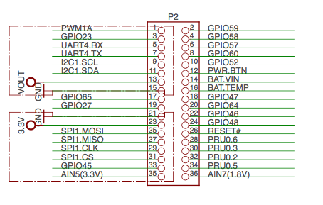

Table 8. P2 Header Pinout
Use scroll bar at bottom of chart to see additional features in columns to the right. When printing this document you will need to print this chart separately.
Header.Pin | Silkscreen | PocketBeagle wiring | Proc Ball | SiP Ball | Mode0 (Name) | Mode1 | Mode2 | Mode3 | Mode4 | Mode5 | Mode6 | Mode7
P2.01 | PWM1A | P2.01 (PWM1A) | U14 | P12 | gpmc_a2 | gmii2_txd3 | rgmii2_td3 | mmc2_dat1 | gpmc_a18 | pr1_mii1_txd2 | ehrpwm1A | gpio1_18
P2.02 | 59 | P2.02 (GPIO1.27) | V17 | T16 | gpmc_a11 | gmii2_rxd0 | rgmii2_rd0 | rmii2_rxd0 | gpmc_a27 | pr1_mii1_rxer | mcasp0_axr1 | gpio1_27
P2.03 | 23 | P2.03 (GPIO0.23) | T10 | P5 | gpmc_d9 | lcd_data22 | mmc1_dat1 | mmc2_dat5 | ehrpwm2B | pr1_mii0_col | - | gpio0_23
P2.04 | 58 | P2.04 (GPIO1.26) | T16 | R15 | gpmc_a10 | gmii2_rxd1 | rgmii2_rd1 | rmii2_rxd1 | gpmc_a26 | pr1_mii1_rxdv | mcasp0_axr0 | gpio1_26
P2.05 | U1_RX | P2.05 (UART4-RX) | T17 | P15 | gpmc_wait0 | gmii2_crs | gpmc_csn4 | rmii2_crs_dv | mmc1_sdcd | pr1_mii1_col | uart4_rxd | gpio0_30
P2.06 | 57 | P2.06 (GPIO1.25) | U16 | T15 | gpmc_a9 | gmii2_rxd2 | rgmii2_rd2 | mmc2_dat7 / rmii2_crs_dv | gpmc_a25 | pr1_mii_mr1_clk | mcasp0_fsx | gpio1_25
P2.07 | U1_TX | P2.07 (UART4-TX) | U17 | R16 | gpm_ wp | gmii2_rxerr | gpmc_csn5 | rmii2_rxerr | mmc2_sdcd | pr1_mii1_txen | uart4_txd | gpio0_31
P2.08 | 60 | P2.08 (GPIO1.28) | U18 | N14 | gpmc_be1n | gmii2_col | gpmc_csn6 | mmc2_dat3 | gpmc_dir | pr1_mii1_rxlink | mcasp0_aclkr | gpio1_28
P2.09 | I2C1_SCL | P2.09 (I2C1-SCL) | D15 | B11 | uart1_txd | mmc2_sdwp | dcan1_rx | I2C1_SCL | - | pr1_uart0_txd | pr1_pru0_pru_r31_16 | gpio0_15
P2.10 | 52 | P2.10 (GPIO1.20) | R14 | R13 | gpmc_a4 | gmii2_txd1 | rgmii2_td1 | rmii2_txd1 | gpmc_a20 | pr1_mii1_txd0 | eQEP1A_in | gpio1_20
P2.11 | I2C1_SDA | P2.11 (I2C1-SDA) | D16 | A11 | uart1_rxd | mmc1_sdwp | dcan1_tx | I2C1_SDA | - | pr1_uart0_rxd | pr1_pru1_pru_r31_16 | gpio0_14
P2.12 | PB | P2.12 (POWER_BTN) |  | T11 | POWER
P2.13 | VOUT | P2.13 (VOUT-5V) |  | K6, K7, L6, L7 | VOUT-5V
P2.14 | BAT + | P2.14 (VIN-BAT) |  | P8, R8, T8 | VIN-BAT
P2.15 | GND | P2.15 (GND) |  |  | GND
P2.16 | BAT - | P2.16 (BAT-TEMP) |  | N6 | BAT-TEMP
P2.17 | 65 | P2.17 (GPIO2.1) | V12 | T7 | gpmc_clk | lcd_memory_clk | gpmc_wait1 | mmc2_clk | pr1_mii1_crs | pr1_mdio_mdclk | mcasp0_fsr | gpio2_01
P2.18 | 47 | P2.18 (PRU0.15i) | U13 | P7 | gpmc_ad15 | lcd_data16 | mmc1_dat7 | mmc2_dat3 | eQEP2_strobe | pr1_ecap0_ecap_capin_apwm_o | pr1_pru0_pru_r31_15 | gpio1_15P
2.19 | 27 | P2.19 (GPIO0.27) | U12 | T5 | gpmc_ad11 | lcd_data20 | mmc1_dat3 | mmc2_dat7 | ehrpwm0_synco | pr1_mii0_txd3 | - | gpio0_27
P2.20 | 64 | P2.20 (GPIO2.0) | T13 | R7 | gpmc_csn3 | gpmc_a3 | rmii2_crs_dv | mmc2_cmd | pr1_mii0_crs | pr1_mdio_data | EMU4 | gpio2_00
P2.21 | GND | P2.21 (GND) |  |  | GND
P2.22 | 46 | P2.22 (GPIO1.14) | V13 | T6 | gpmc_ad14 | lcd_data17 | mmc1_dat6 | mmc2_dat2 | eQEP2_index | pr1_mii0_txd0 | pr1_pru0_pru_r31_14 | gpio1_14
P2.23 | +3.3V | P2.23 (VOUT-3.3V) |  | F6 & F7 & G6 & G7 | VOUT-3.3V
P2.24 | 48 | P2.24 (GPIO1.12) | T12 | P6 | gpmc_ad12 | lcd_data19 | mmc1_dat4 | mmc2_dat0 | eQEP2A_in | pr1_mii0_txd2 | pr1_pru0_pru_r30_14 | gpio1_12
P2.25 | SPI1_MOSI | P2.25 (SPI1-MOSI) | E17 | C13 | uart0_rtsn | uart4_txd | dcan1_rx | I2C1_SCL | spi1_d1 | spi1_cs0 | pr1_edc_sync1_out | gpio1_09
P2.26 | RST | P2.26 (NRESET) | A10 | R11 | nRESETIN_OUT | - | - | - | - | - | - | -
P2.27 | SPI1_MISO | P2.27 (SPI1-MISO) | E18 | C12 | uart0_ctsn | uart4_rxd | dcan1_tx | I2C1_SDA | spi1_d0 | timer7 | pr1_edc_sync0_out | gpio1_08
P2.28 | PRU0_6 | P2.28 (PRU0.6) | D13 | C3 | mcasp0_axr1 | eQEP0_index | - | mcasp1_axr0 | EMU3 | pr1_pru0_pru_r30_6 | pr1_pru0_pru_r31_6 | gpio3_20
P2.29 | SPI1_CLK | P2.29 (SPI1-CLK) | C18 | C5 | eCAP0_in_PWM0_out | uart3_txd | spi1_cs1 | pr1_ecap0_ecap_capin_apwm_o | spi1_sclk | mmc0_sdwp | xdma_event_intr2 | gpio0_7
P2.30 | PRU0_3 | P2.30 (PRU0.3) | C12 | B1 | mcasp0_ahclkr | ehrpwm0_synci | mcasp0_axr2 | spi1_cs0 | eCAP2_in_PWM2_out | pr1_pru0_pru_r30_3 | pr1_pru0_pru_r31_3 | gpio3_17
P2.31 | SPI1_CS | P2.31 (SPI1-CS1) | A15 | A4 | xdma_event_intr0 | - | timer4 | clkout1 | spi1_cs1 | pr1_pru1_pru_r31_16 | EMU2 | gpio0_19
P2.32 | PRU0_2 | P2.32 (PRU0.2) | D12 | B2 | mcasp0_axr0 | ehrpwm0_tripzone_input | - | spi1_d1 | mmc2_sdcd | pr1_pru0_pru_r30_2 | pr1_pru0_pru_r31_2 | gpio3_16
P2.33 | 45 | P2.33 (GPIO1.13) | R12 | R6 | gpmc_ad13 | lcd_data18 | mmc1_dat5 | mmc2_dat1 | eQEP2B_in | pr1_mii0_txd1 | pr1_pru0_pru_r30_15 | gpio1_13
P2.34 | PRU0_5 | P2.34 (PRU0.5) | C13 | B3 | mcasp0_fsr | eQEP0B_in | mcasp0_axr3 | mcasp1_fsx | EMU2 | pr1_pru0_pru_r30_5 | pr1_pru0_pru_r31_5 | gpio3_19
P2.35 | A5/86 | P2.35 (AIN5/GPIO86) | B8 | C8 | ain5
P2.35 | A5/86 | P2.35 (AIN5/GPIO86) | U5 | F3 | lcd_vsync | gpmc_a8 | gpmc_a1 | pr1_edio_data_in2 | pr1_edio_data_out2 | pr1_pru1_pru_r30_8 | pr1_pru1_pru_r31_8 | gpio2_22

7.2 mikroBUS socket connections
mikroBUS and, by extension "mikroBUS Click boards", are trademarks of MikroElektronika. We do not make any claims of compatibility nor adherence to their specification. We've just seen that many of the Click boards "just work".
The Expansion Headers on PocketBeagle have been designed to accept up to two Click Boards added to the header pins at the same time. This provides an exciting opportunity to add functionality easily to PocketBeagle from 'hundreds of existing add-on Click Boards'.
The mikroBUS standard comprises a pair of 1×8 female headers with a standardized pin configuration. The pinout (always laid out in the same order) consists of three groups of communications pins (SPI, UART and I2C), six additional pins (PWM, Interrupt, Analog input, Reset and Chip select), and two power groups (+3.3V and 5V).

Figure 45. mikroBUS
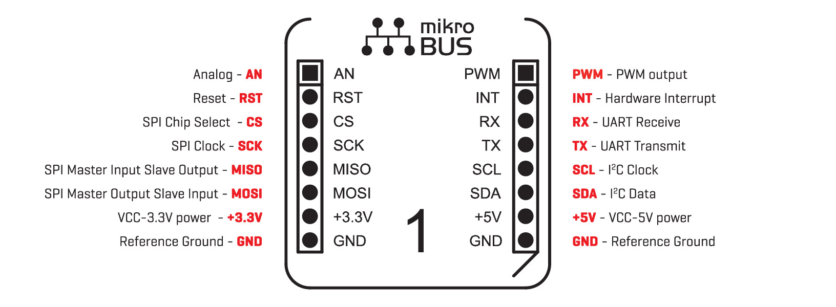
The Expansion Header pin alignment enables 2 Click Boards on the top side of PocketBeagle using the inside rails of the headers. This leaves the outside rails open to be accessed from either the top or the bottom of PocketBeagle. Place each Click Board into the position shown in Figure 46, with one Click Board facing each direction. When choosing Click boards, make sure you are checking that they meet the 3.3V requirements for PocketBeagle. A growing number of community members are trying out various Click Boards and posting results on the 'PocketBeagle Wiki mikroBus Click Boards page'.

Figure 46. PocketBeagle Both Headers
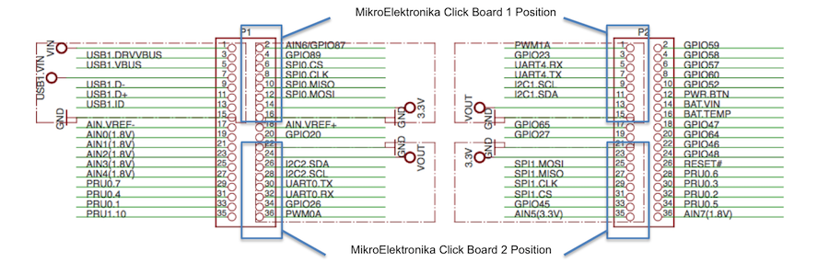

7.3 Setting up an additional USB Connection
You can add an additional USB connection to PocketBeagle easily by connecting a microUSB breakout. By default in the current software, the system should be configured to use this port as a host. Keep up to date on this project on the 'PocketBeagle Wiki FAQ'.
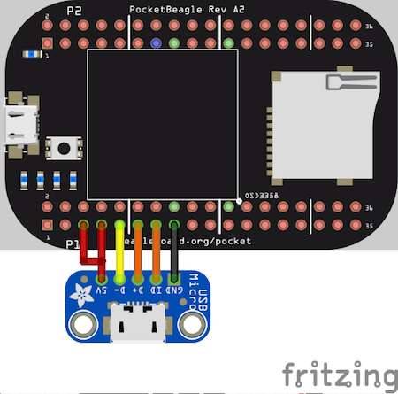

8.0 PocketCape Support
This is a placeholder for recommendations for those building their own PocketCape designs. If you'd like to join the conversation 'check out the discussion on the google group for PocketBeagle'

9.0 PocketBeagle Mechanical

9.1 Dimensions and Weight
Size: 2.21” x 1.38” (56mm x 35mm)
Max height: .197” (5mm)
PCB size: 55mm x 35mm
PCB Layers: 4
PCB thickness: 1.6mm
RoHS Compliant: Yes
Weight: 10g
Rough model can be found at github.com/beagleboard/pocketbeagle/tree/master/models

10.0 Additional Pictures

Figure 47. PocketBeagle Front BW
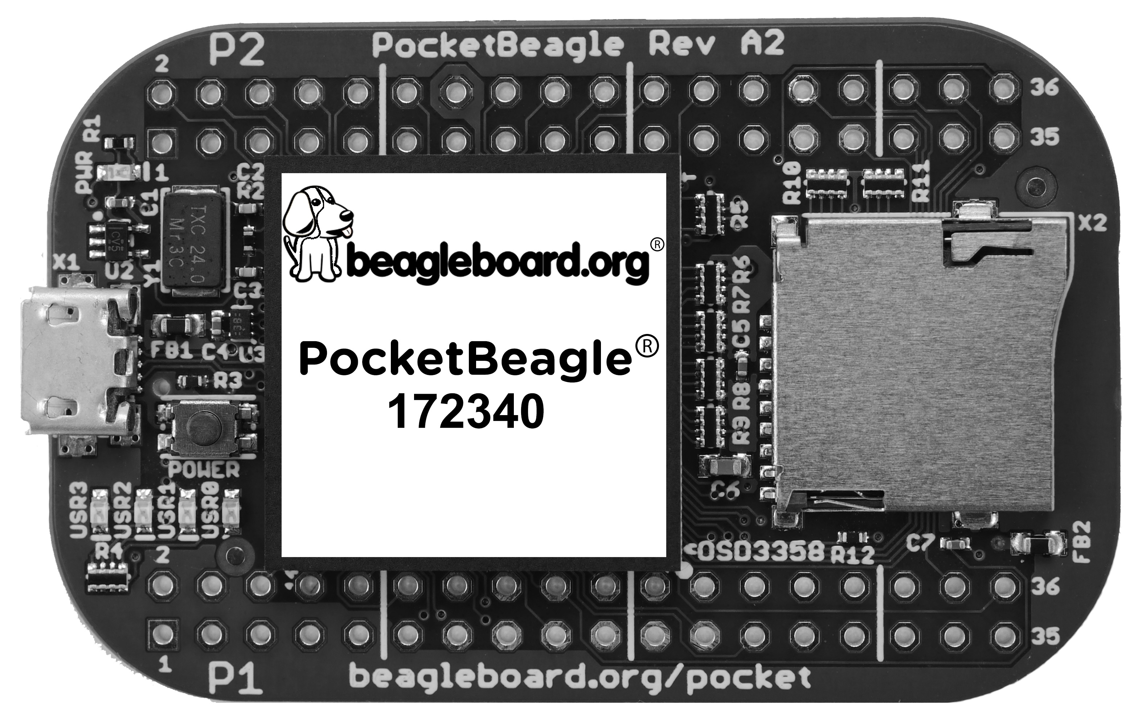

Figure 48. PocketBeagle Back BW
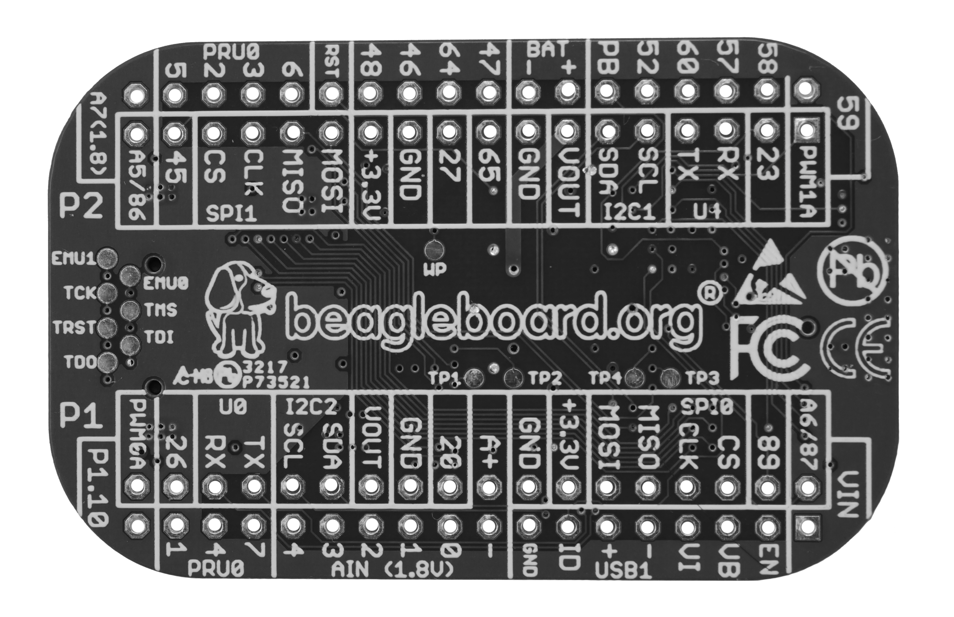

11.0 Support Information
All support for this design is through the BeagleBoard.org community at:
- beagleboard@googlegroups.com or
- beagleboard.org/discuss.

11.1 Hardware Design
Design documentation can be found on the wiki. https://github.com/beagleboard/pocketbeagle Including:
- Schematic in PDF https://github.com/beagleboard/pocketbeagle/blob/master/PocketBeagle_sch.pdf
- Schematic and layout in EAGLE https://github.com/beagleboard/pocketbeagle/tree/master/EAGLE
- Schematic and layout in KiCAD https://github.com/beagleboard/pocketbeagle/tree/master/KiCAD
- Bill of Materials https://github.com/beagleboard/pocketbeagle/blob/master/PocketBeagle_BOM.csv
- System Reference Manual https://github.com/beagleboard/pocketbeagle.

11.2 Software Updates
It is a good idea to always use the latest software. Instructions for how to update your software to the latest version can be found at:
Download the latest software files from beagleboard.org/latest-images

11.5 Export Information
- ECCN: EAR99
- CCATS: G173833
- Documentation: github.com/beagleboard/pocketbeagle/blob/master/regulatory/PocketBeagle_Export_Classification.pdf

11.4 RMA Support
If you feel your board is defective or has issues and before returning merchandise, please seek approval from the manufacturer using beagleboard.org/support/rma. You will need the manufacturer, model, revision and serial number of the board.

11.5 Getting Help
If you need some up to date troubleshooting techniques, the Wiki is a great place to start github.com/beagleboard/pocketbeagle/wiki.
If you need professional support, check out beagleboard.org/resources.

